Open Compound Noun

🔹 What is Open Compound Noun
# Source: AI Source: Provided by: [Data Path: Persons Table -> ID Column: 1, Name_En Column: Motasem Essam] -> From: [Chatgpt (GPT-4-turbo)] on [7/26/2025]
An open compound noun is made up of two or more separate words that function together as a single noun, even though they are written with spaces.
✨ The words are written separately, but they form one idea.

✅ Definition:
# Source: AI Source: Provided by: [Data Path: Persons Table -> ID Column: 1, Name_En Column: Motasem Essam] -> From: [Chatgpt (GPT-4-turbo)] on [7/26/2025]
Open compound nouns are multi-word expressions written with spaces that behave as a single noun in meaning.

📚 Examples of Open Compound Nouns:
# Source: AI Source: Provided by: [Data Path: Persons Table -> ID Column: 1, Name_En Column: Motasem Essam] -> From: [Chatgpt (GPT-4-turbo)] on [7/26/2025]
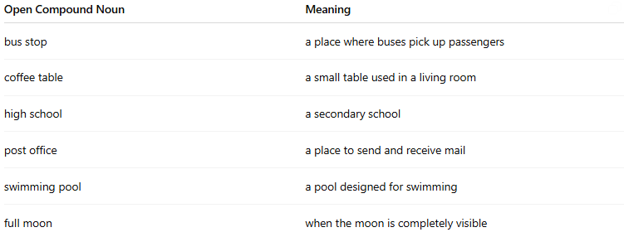
Open Compound Noun | Meaning
bus stop | a place where buses pick up passengers
coffee table | a small table used in a living room
high school | a secondary school
post office | a place to send and receive mail
swimming pool | a pool designed for swimming
full moon | when the moon is completely visible

📝 Example Sentences:
# Source: AI Source: Provided by: [Data Path: Persons Table -> ID Column: 1, Name_En Column: Motasem Essam] -> From: [Chatgpt (GPT-4-turbo)] on [7/26/2025]
- We waited at the bus stop for 10 minutes.
- She bought a new coffee table for the living room.
- I went to the post office this morning.
- The sky was bright under the full moon.

🧠 Key Feature:
# Source: AI Source: Provided by: [Data Path: Persons Table -> ID Column: 1, Name_En Column: Motasem Essam] -> From: [Chatgpt (GPT-4-turbo)] on [7/26/2025]
- Even though each word is written separately, the meaning comes from both together.
- You cannot remove one word or switch them without losing the meaning.

🔁 Comparison Table:
# Source: AI Source: Provided by: [Data Path: Persons Table -> ID Column: 1, Name_En Column: Motasem Essam] -> From: [Chatgpt (GPT-4-turbo)] on [7/26/2025]

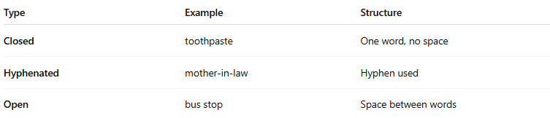
Type | Example | Structure
Closed | toothpaste | One word, no space
Hyphenated | mother-in-law | Hyphen used
Open | bus stop | Space between words

✅ Summary:
# Source: AI Source: Provided by: [Data Path: Persons Table -> ID Column: 1, Name_En Column: Motasem Essam] -> From: [Chatgpt (GPT-4-turbo)] on [7/26/2025]
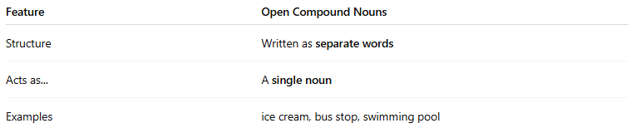
Feature | Open Compound Nouns
Structure | Written as separate words
Acts as... | A single noun
Examples | ice cream, bus stop, swimming pool

